Chapter 3 Problems
Problem 20:
There are 2³² = 4,294,967,296 possible sequence numbers.
- The sequence number does not increment by one with each segment. Rather, is incremented by the number of bytes of data sent. So the size of the MSS is irrelevant -- the maximum size file that can be sent from A to B is simply the number of bytes representable by 2³² bytes (4.19 Gbytes).
- The number of segments is
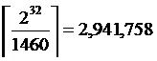
66 bytes of header get added to each segment giving a total of 194,156,094 bytes of header.
The total number of bytes transmitted is 2³² + 194,156,094 = 4,489,123,390 bytes (3,591*10⁷ bits). Thus it would take 3,591 seconds = 59 minutes to transmit the file over a 10 Mbps link.

Problem 27:
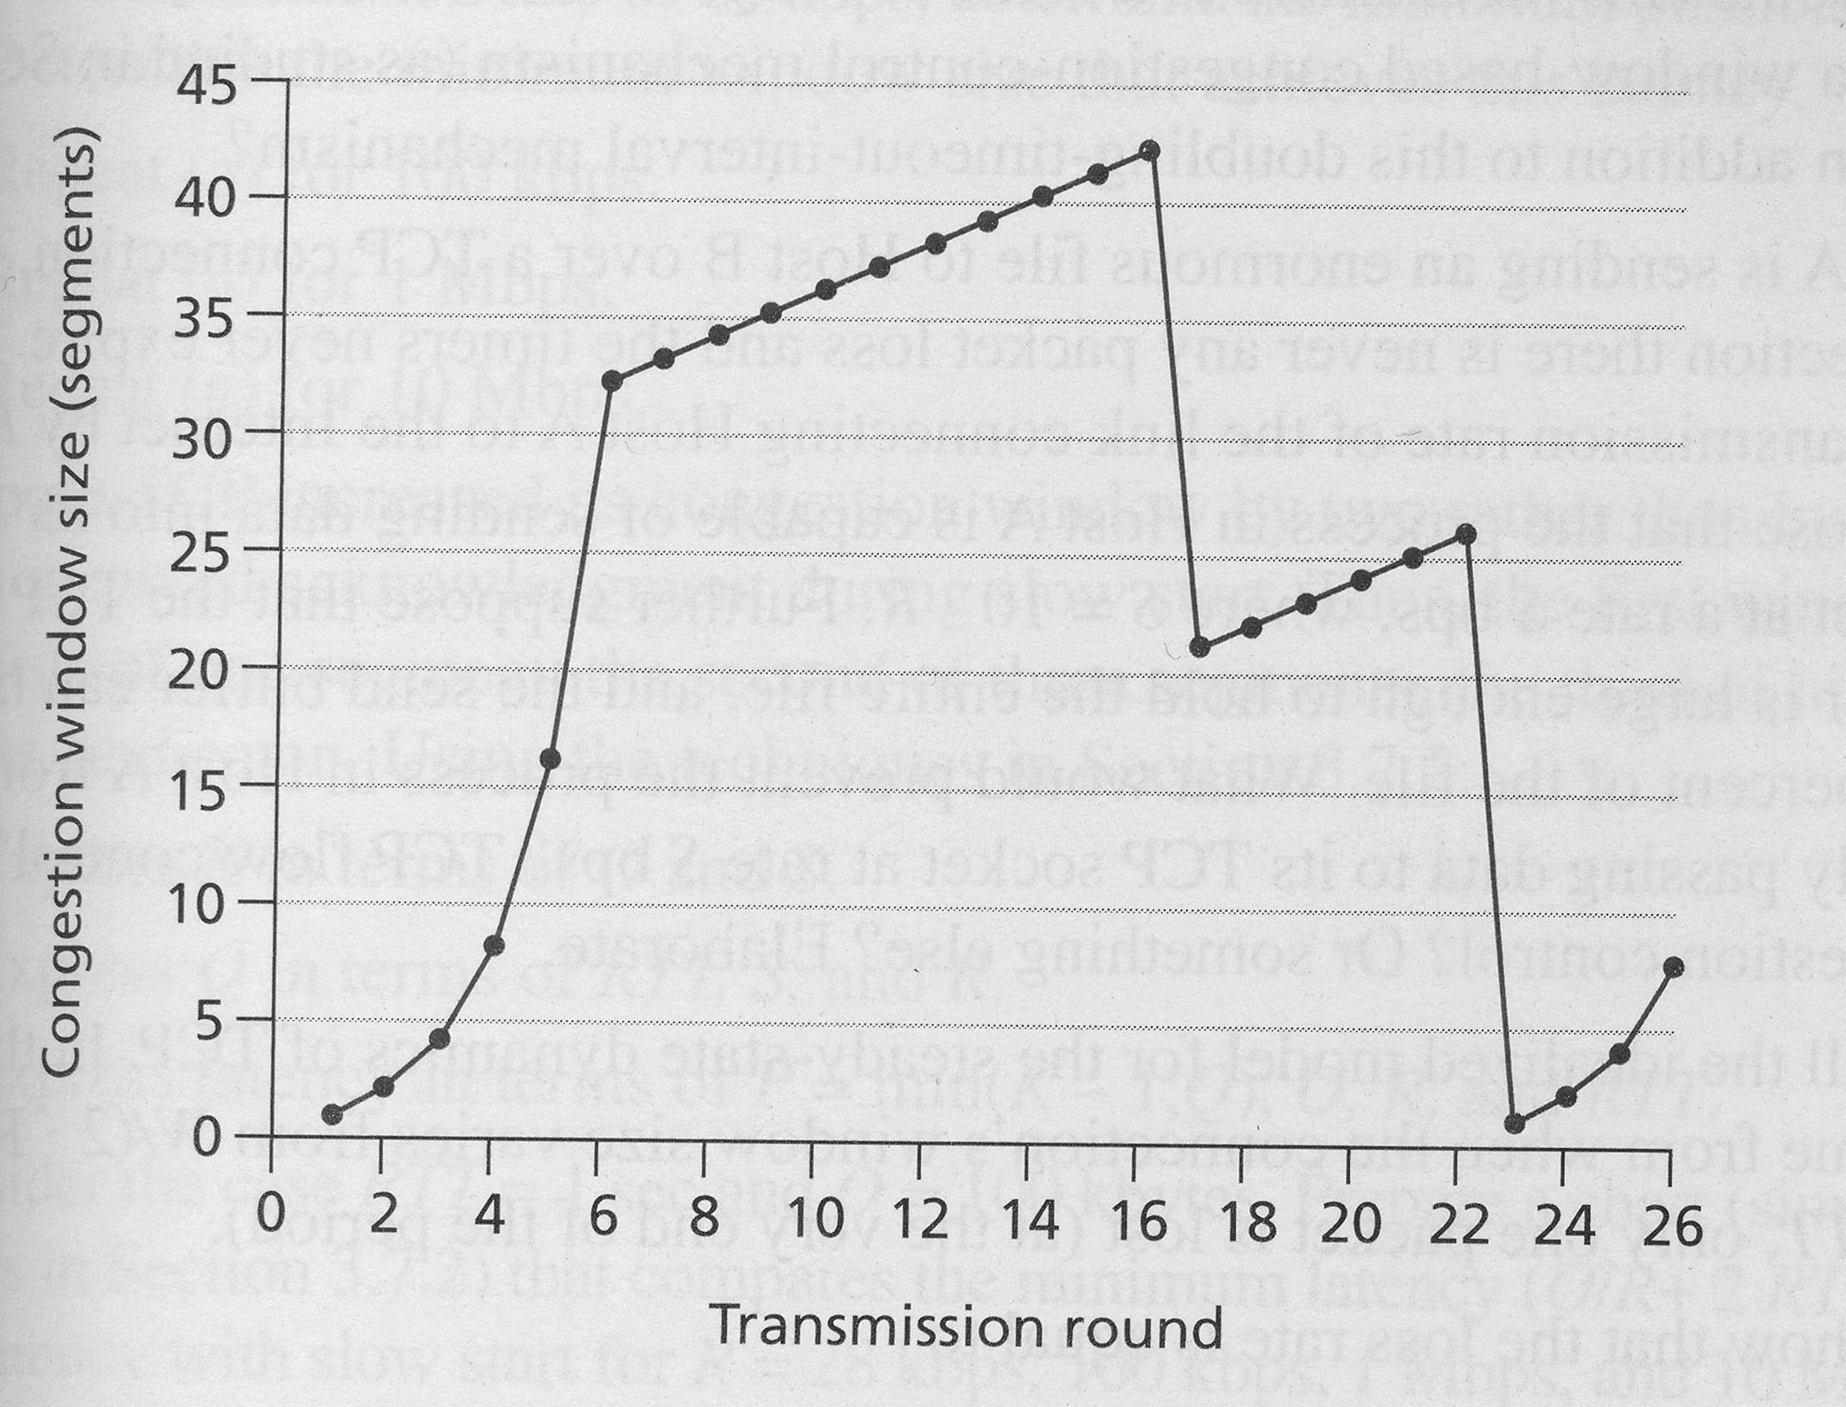

- TCP slowstart is operating in the intervals [1,6] and [23,26]
- TCP congestion advoidance is operating in the intervals [6,16] and [17,22]
- After the 16th transmission round, packet loss is recognized by a triple duplicate ACK. If there was a timeout, the congestion window size would have dropped to 1.
- After the 22nd transmission round, segment loss is detected due to timeout, and hence the congestion window size is set to 1.
- The threshold is initially 32, since it is at this window size that slowtart stops and congestion avoidance begins.
- The threshold is set to half the value of the congestion window when packet loss is detected. When loss is detected during transmission round 16, the congestion windows size is 42. Hence the threshold is 21 during the 18th transmission round.
- The threshold is set to half the value of the congestion window when packet loss is detected. When loss is detected during transmission round 16, the congestion windows size is 42. Hence the threshold is 21 during the 18th transmission round.
- During the 1st transmission round, packet 1 is sent; packet 2-3 are sent in the 2nd transmission round; packets 4-7 are sent in the 3rd transmission round; packets 8-15 are sent in the 4th transmission round; packets15-31 are sent in the 5th transmission round; packets 32-63 are sent in the 6th transmission round; packets 64 – 96 are sent in the 7th transmission round. Thus packet 70 is sent in the 7th transmission round.

Problem 30:

In this problem, there is no danger in overflowing the receiver since the receiver’s receive buffer can hold the entire file. Also, because there is no loss and acknowledgements are returned before timers expire, TCP congestion control does not throttle the sender. However, the process in host A will not continuously pass data to the socket because the send buffer will quickly fill up. Once the send buffer becomes full, the process will pass data at an average rate or R << S.

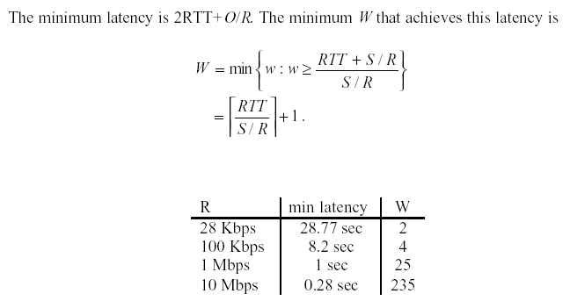
Problem 34:

